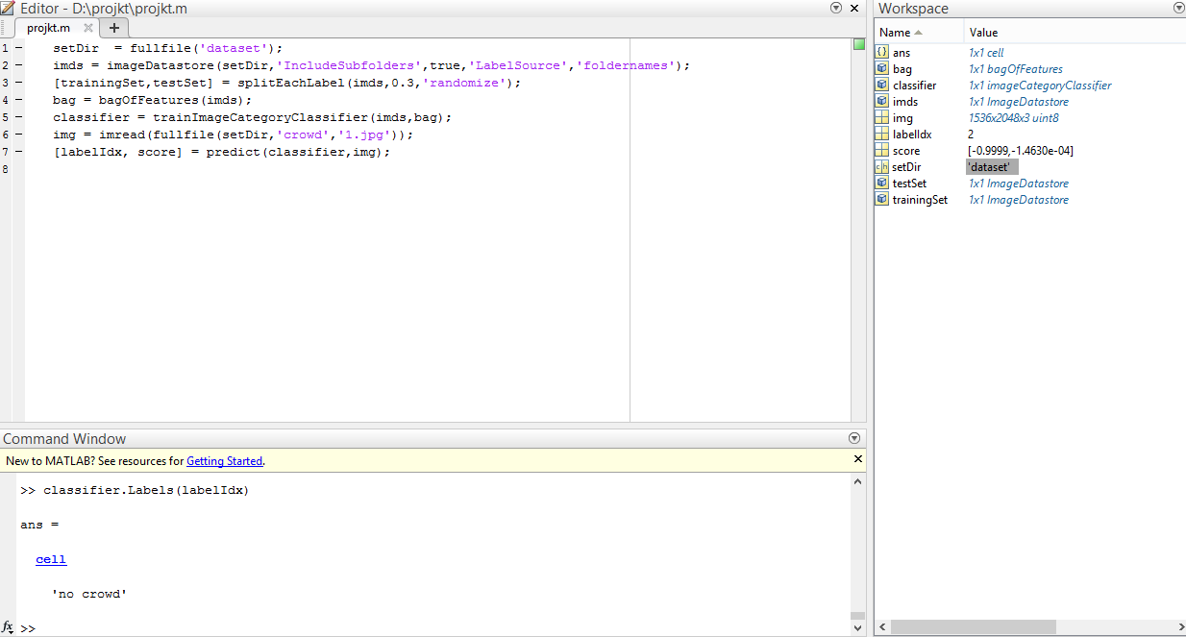

Code:

setDir = fullfile('dataset');

imds = imageDatastore(setDir,'IncludeSubfolders',true,'LabelSource','foldernames');

[trainingSet,testSet] = splitEachLabel(imds,0.3,'randomize');

bag = bagOfFeatures(imds);

classifier = trainImageCategoryClassifier(imds,bag);

img = imread(fullfile(setDir,'crowd','1.jpg'));

[labelIdx, score] = predict(classifier,img);

The code works fine but takes around 12-15 minutes to compile just for a dataset of 20 pictures.

img = imread(fullfile(setDir,'crowd','1.jpg'));

The command given above is typed in the command window and the directory and file name is specified to upload an image using imread and then the predict command is used to evaluate the image given.

[labelIdx, score] = predict(classifier, mg);

Finally ‘classifier.Labels(labelIdx)’ is used in the command window to get the output of ‘crowd’ or ‘no crowd’. Since the code takes a lot of time for processing and only works on the latest versions of MATLAB not widely available so we have not included it in our final project code.

Some of the inputs and results are given below for convenience.

Input image:

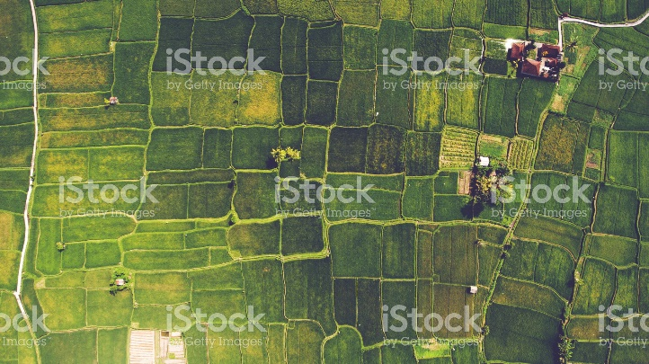

Output result: No crowd

Input Image:

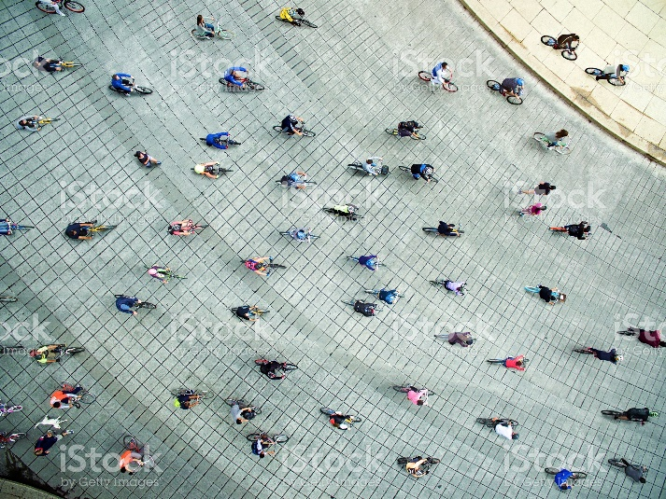

Output Result: Crowd

Input Image:



Output Result: Crowd

Incorrect Result:

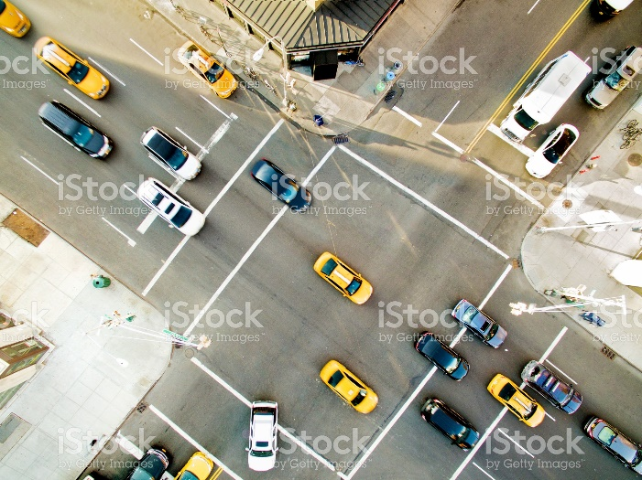

Output Result: Crowd

We ran the process 10 times for different images not part of the data set, out of which 8 were correct. The image given above was for example ruled as a crowd image. It can be due to the small dataset used keeping in mind the long time for code processing. If the data set was increased to 50 images (25 for each crowd and non-crowd) then the results may be more accurate. Finally, we used images with high resolution (2048x1150 pixels) have more accuracy at the expense of processing time taken.

Note: Most of the code used is widely available in the MATLAB Documentation main change was to target our data set directory and compiling the dataset and lowering the time it takes for processing by using images with lower resolution.

References: https://www.mathworks.com/help/vision/ug/image-classification-with-bag-of-visual-words.html